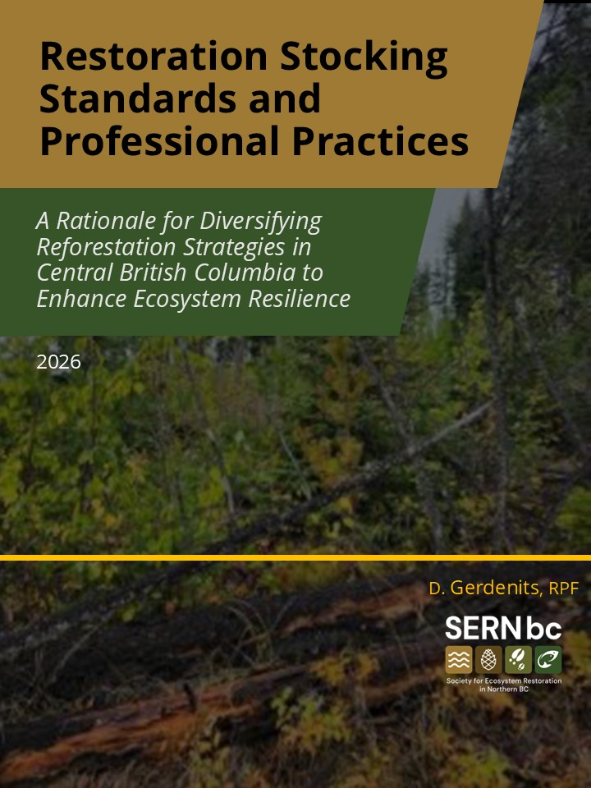

Dedication
This work is dedicated to the memory of Bruce Rogers, RPBio, Omineca Regional Ecologist, whose work, field time with me, inspiration, passion, research and unwavering dedication to ecosystems continue to inspire all of us.

Authorship and Revision History
Prepared by: Diana Gerdenits, RPF, Gerdenits and Associates Natural Resource Consulting for the Society for Ecosystem Restoration in Northern BC (SERNbc), September 2026


Contributors
Stocking standards working group and community of practice: Alexandre Bevington, Taisa Brown, Doug Casimel, Kirsten Chapman, Alana Clason, John DeGagne, Craig Farnden, Brandon Geldart, Diana Gerdenits, Britney Grunerud, Nick Hamilton, Caitlin Harrison, Cheryl Johnston-Schuetz, Pam Ketlo, Duncan McColl, Jason Parsons, Jason Regnier, Isaiah Reynolds, Irene Ronalds, Bruce Rogers, Daniel Sklar, and John Wallis

Reviewers: Brandon Geldart, Britney Grunerud, Bruce Rogers, John Wallis, and Mae Whyte
Version Number | Revision Date | Description of Changes
1.0 | 28 September 2026

Table of Contents

Contents
Dedication 2
Authorship and Revision History 2
Contributors 2
Table of Contents 3
Contents 3
List of Tables 4
List of Figures 4
Executive Summary 5
1.0 Key Terms 5
2.0 Introduction 7
2.1 Historical Context: Key aspects of how Lodgepole pine became over-represented on the landscape 8
2.2 Historical Context: Impacts of Lodgepole pine on the landscape 10
2.3 Historical Context: Facilitated migration of western larch 12
2.4 Historical Context: Broadleaves and Shrub Species 13
2.5 Historical Context: Temporal and Spatial Stand Densities Matter 14
3.0 SMZ Table Resolutions and Recommendations 15
3.1 Tie Standard Units More Closely to Ecosystems: Application of QRP and Practices 15
3.2 Implementation of Mandatory Minimums of Keystone Species 17
3.3 Addressing Western Larch and Facilitated Migration Motivations 17
3.4 Supporting early seral developments in SMZs 18
3.5 Stand Densities: Methods to reduce the risk of high densities 18
4.0 Anticipated Outcomes 19
5.0 Restoration Standards and Professional Practices 19
5.1 Defining Standard Units within the SMZ 20
5.2 Simple and Compound Ecosystem Delineation for SUs within the SMZ 22
5.3 Professional Accountability Documentation 25
5.4 Establishment of Mandatory Tree Species Minimums 25
5.5 MITD and Target Preferred and Acceptable Trees (TSSpa) – creating clumps and gaps 26
5.6 Addressing Vegetative Competition 26
5.7 Broadleaves 29
5.8 Conifer and Broadleaf Maximum Density Management 30
5.9 Facilitated Migration of yellow pine and western larch 31
5.10 Free-growing and Regeneration Delay 32
6.0 References 32
Appendix 1: Professional Accountability Documents 35
Appendix 2: Restoration Stocking Standards SMZ 37

List of Tables
Table 1: Participants and their organizations. 7
Table 2: SMZ Meeting Dates and Discussion of Key Topics 8

List of Figures
Figure 1: Kope et al, 2012. Results of SPP by BA, Central BC, Stands Aged 20-40 Yrs. 9
Figure 2: Determining Qualifying Listed Site Series as SU's 21
Figure 3: Example of Edatopic Grid for SBSdw3 and Lead SPP Correlation 23
Figure 4: Example of Inclusion of Transitional Areas to Small Linear SU's 25
Figure 5: Broadleaf and Vegetation Competition Decision Matrix for SMZ 28
Figure 6: Example of Potential FG and Broadleaf Inclusion 30
Figure 7: Examples of Conifer FG and NFG 30

Executive Summary
This report, The Restoration Standards Rationale Report by SERNbc, outlines the process and rationale for implementing restoration standards and silvicultural professional practices in special management zones (SMZs) in north-central British Columbia. Our primary objective is to enhance ecosystem resilience through diversified reforestation strategies consistent with the goals set forth in the Shovel and Island Lake Ecosystem Restoration Plan (Daust & Price, 2019). The process began with a draft set of standards and practices authored by Diana Gerdenits, RPF, followed by a peer-reviewing team that held meetings to discuss a range of implications of selected stocking standards on the special management zones and their priorities. This report and the standards form the results of those meetings, decisions, and priorities.
Purpose: The rationale aims to address the ecological impacts of lodgepole pine monocultures and proposes reforestation strategies and practices to improve ecosystem resilience that are ecosystem- and site-specific, focusing on adherence to ecosystem edaphics and mosaics.
Key Issues: This report highlights the historical and operational impacts from various practices which led to overrepresentation of lodgepole pine, dense juvenile stands, and large standard unit applications that in turn resulted in lost ecosystem diversity across the landscape. This impacted hydrology, intensified wildfire behaviour, and reduced wildlife habitat. These standards attempt to reduce facilitated migration of western larch (Larix occidentalis) by shifting the focus back to enhancing Douglas-fir (Pseudotseuga menziesii) and broadleaf populations.
Proposed Actions: The proposed actions include:
- Identifying and implementing mandatory minimums for keystone tree species, as defined by the working group in Sec. 1.0.
- Promoting mixed-species planting.
- Enhancing early seral development trajectories, by allowing space for shrubs and broadleaves and time.
- Managing stand densities to reduce wildfire risk and improve wildlife habitat.
- Reducing the pressure to plant high lodgepole pine densities at establishment phases (nurse tree species).
- Understanding that this is a beginning and will be reviewed into the future as part of continuous improvement.
Expected Outcomes: The expected outcomes include improved biodiversity, enhanced soil health, better hydrologic function, and increased resilience to wildfires and climate change by ensuring that stocking standards are more closely aligned with reference ecosystems. The document emphasizes the importance of collaboration in achieving these goals.

1.0 Key Terms
BEC: Preferred acronym within this document referring to the diagnostic ecological system in BC referred to as Biogeoclimatic Ecosystem Classification System. Refer to LMH 25.
ERP: Acronym for Ecosystem Restoration Plan, such as the one written by David Daust and Karen Price for the Shovel and Island Lake Wildfire area in 2019.
Ghost Trees: Trees present in a plot being assessed, however not considered for the purposes of some level of free-growing assessments or inventory. (historically, silviculture labels but persist in limits on ‘countable conifers’).
Keystone Species: Ecologically significant identified tree species which is considered a fundamentally important tree to be present in the mature future forest as they provide a disproportionate critical value to the health of the ecosystem they are associated with. They have mandatory minimum presence requirements at free growing within the professionally designated Standard Units. Within these stocking standards they are referred to as Mandatory Minimum Tree Species, and minimum presence at free growing.
LMH 25: Land Management Handbook 25, Field Manual for Describing Terrestrial Ecosystems 2nd Edition (2010), a field manual designed to support completing the Province of BC’s ecosystem field forms in various inventories.
Nurse Trees: The historic trend in operational forestry where, due to clearcutting and the desire to meet stocking objectives for free-growing, establishment of species which exhibit accelerated juvenile growth, particularly in clearcut environments. They represent a tree species that will meet a free-growing objective but do not necessarily need to be present at maturity.
QP: Acronym referring to a Qualified Person, to whom some level of experience, training and/or expertise allows that they can conduct specific works or data collection that a QRP can take professional responsibility for.
QRP: Acronym referring to a Qualified Registered Professional to whom the province regards as having met the professional practice and expertise to make professional decisions and prescriptions.
SERNbc: Preferred acronym format for the non-profit named, Society for Ecosystem Restoration in Northern British Columbia.
SMZ: Acronym for Special Management Zones – related to the zonation within the Ecosystem Restoration Plans where sawlog and fibre production is not the primary objective.
Standard Unit: Professionally designated silviculture management unit. Based on ecological site series, correlation to listed plant communities, critical site and soil factors, and potential identified wildlife, habitat, or other management priority described spatially within the ERP. Signed and sealed with an Accountability Document rationale which can be made available for review.
SS1, SS2, SS3, SS4: These represent the acronyms within the Land Management Handbook 25 describing unique ecological site series. Where there is an area being developed into a standard unit where more than one site series (SS) is described: thus SS1/SS2 would describe a situation where there is 50% SS1 and 50% SS2 (refer to LMH 25).
SE Simple Ecosystem Definition: Preferred ecosystem assignment for an SU. Describes a singular site series for the SU. Described in LMH 25 as SS1.
SCE Simple Compound Ecosystem Definition: Typical and normal conditions for SU assignment, particularly in hummocky, mounded terrain found within esker and drumlin terrain. Described in LMH 25 as SS1(SS2), SS1/SS2.
CCE Complex Compound Ecosystem Definition: Typically, an unacceptable assignment of multiple site series combined in a standard unit to which no one management regime or assignment of keystone species can be made. Described in LMH 25 as (SS1/SS2/SS3) or (SS1/SS2/SS3/SS4). Professionals making these assignments require additional rationales (i.e., 3 site series, but all very hydric to hygric and similar for critical site and soil factors).
Transition Zone: Defined within this restoration standard is the acknowledgement that in some circumstances transitions between lower slopes and upland slopes there exist areas of 'transition' where the soil moisture/nutrient regimes are blurred between the two eco-site types and difficult to define as either; also known as an ecotone. This standard request that, as lower riparian site series are typically small patch, these transition zones be included within the small patch and not the upland type, as riparian site series often require the most protection.

2.0 Introduction
The Society for Ecosystem Restoration in Northern British Columbia (SERNbc) retained the professional services of Gerdenits and Associates (GA) to create a draft set of stocking standards to assist in restoration activities in areas impacted by wildfire, specifically in the Shovel and Island Lake wildfires. The idea was to provide standards and practices that would respect the goals and objectives set forth in the Ecosystem Restoration Plan (ERP, Daust & Price 2019). This draft was delivered in March 2023. This was considered an initial step for SERNbc to have these standards reviewed and discussed within a broader reviewing practice community. In September of 2024, SERNbc requested that GA coordinate establishment of a community of practice working group for reviewing and discussing these standards. The first meeting occurred at UNBC on October 22, 2024. Meeting monthly, this group provided feedback and many experts were invited to speak at these meetings. To date, we have primarily focused on developing restoration standards and professional practices for the special management zones. We hope to continue this process and develop standards and practices for Timber Restoration Zones as well. This report is the rationale and analysis of the group regarding the standards and practices for the special management zones.
The following members participated in this process:

Table 1: Participants and their organizations.
Participants Names | Company/ Organization
John DeGagne, RPF | Government: Director of Restoration and Recovery
Nick Hamilton, P.Ag. | Government: Rangeland Ecologist
Cheryl Johnston-Schuetz, RPF | Industry/ Consulting: Canfor/ Independent consultant
Taisa Brown, RPF | Government: Silviculture Performance Assessment Specialist
Craig Farnden, PhD, RPF | Consulting: Inventory and Analysis Specialist
Duncan McColl, RPBio. | Government: Section Head Landbase and Stewardship.
Daniel Sklar, RPBio. | Government: Regional Ecologist, Omenica
Britney Grunerud, RPF | Consulting: Professional Forester, Ironwood Resource Professionals
Kirsten Chapman | First Nations: Nadleh Whut’en Land Referrals Coordinator
Alexandre Bevington, MSc | Education: UNBC Assistant Professor/ Geomorphologist
Alana Clason, PhD | Researcher: Bulkley Valley Research Centre/ Research Associate
Caitlin Harrison, RPF | Government: Harvesting and Silviculture Practices
Brandon Geldart, RFT | Consultant: Coordinator SERNbc
Irene Ronalds, RPBio | Consultant: Coordinator SERNbc
Pam Ketlo | First Nations: Nadleh Whut’en Lands and Resources Manager
Doug Casimel | Stellat’en Stewardship Department Manager
Jason Regnier, RPF | First Nations: Professional Forester Consultant
Isaiah Reynolds | First Nations: Stellat’en Stewardship Fisheries Manager
Jason Parsons | First Nations: Nadleh Whut’en Stewardship
John Wallis, RPF, SAS | Consulting/Trainer Silviculture Survey Expert
Bruce Rogers, RPBio., PAg. | Government: Late Regional Ecologist for Omenica
Diana Gerdenits, RPF, SAS | Consultant: Gerdenits and Associates, professional forester
*Special mention: Bruce Rogers reviewed the original draft utilizing climate-based seed transfer and provided feedback.

The following is a very brief listing of key discussion items and dates of meetings:

Table 2: SMZ Meeting Dates and Discussion of Key Topics
Dates of all meetings | Focus of discussions
October 22, 2024 | Overall priorities and emphasis
November 15, 2024 | Landscape level stocking standards, target minimums, and current legislation on FG
January 16, 2025 | Broadleaves and mixedwood systems, old growth attributes, wildlife impacts
February 19, 2025 | IBWG presentation, GY models, stand densities, countable tree methods
March 12, 2025 | Forest Stand Dynamics, temporal/spatial impacts, values, density and quality of fibre
April 30, 2025 | Decision Matrices, higher level planning, tools for management decisions on landscape
September 26, 2025 | Field Day to review issues of spacing, stand development dynamics, Pli monocultures, keystone species, and broadleaves
November 19, 2025 | Review and comments on final numbers and stats for SMZ stocking standards

2.1 Historical Context: Key aspects of how Lodgepole pine became over-represented on the landscape
In central British Columbia (BC), clearcutting combined with free-growing policies have led to the overrepresentation of lodgepole pine (Pinus contorta var. latifolia) as the primary reforestation species, significantly altering landscape-level ecological dynamics. These policies, intended to streamline forest regeneration, instead resulted in large areas managed as single standard units with lodgepole pine as the dominant species, which reduced ecosystem diversity and impacted hydrology, wildfire behaviour, and wildlife habitat (Mather et al., 2010). Communities consulted during the ERP process expressed strongly that forest management decisions like stocking and restoration standards should be mandated by the communities themselves. Stand development monitoring work compiled in 2012 demonstrates the impact on developing stands across central BC where lodgepole pine regeneration has empirically been found to dominate the landscape. Our regenerating forests are composed largely of lodgepole pine.
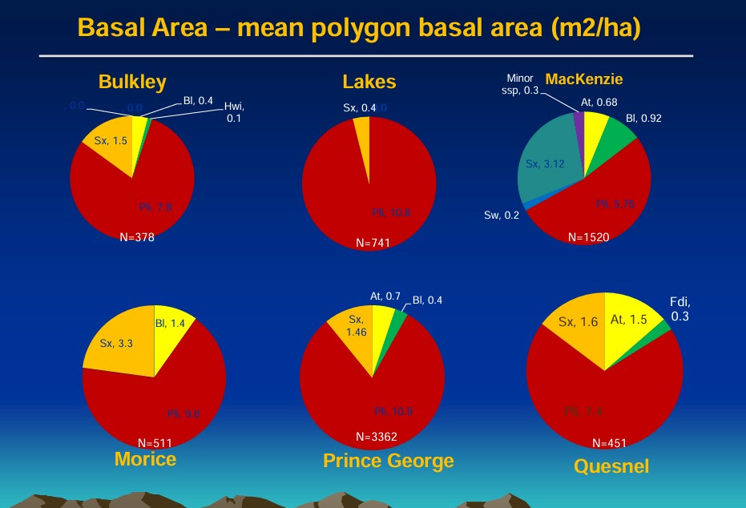

Figure 1: Kope et al, 2012. Results of SPP by BA, Central BC, Stands Aged 20-40 Yrs.
Image taken from Harry Kope, Resource Practices Branch, PowerPoint presentation of the SDM Team: Kevin Astridge, Frank Barber, Harry Kope, Dave Weaver, Stefan Zeglen (team lead): PPT — Stand Development Monitoring PowerPoint Presentation

Clearcutting and Free-Growing Policies
Clearcutting, a prevalent logging practice in BC, involves removing almost all trees in a designated area, often followed in many ecosystems by planting lodgepole pine due to its adaptability to open, disturbed sites (BC Ministry of Forests, 1995). Free-growing policies, established under BC's Forest Practices Code and continuing until today, require plantations to meet minimum tree density, height, and health criteria within a standard unit to be declared "free-growing" (Mather et al., 2010). However, not following or enforcing ecological criteria for standard unit typing has enabled the industry to treat large, ecologically diverse areas as single units with uniform stocking standards favouring lodgepole pine (Mather et al., 2010). This practice has led to extensive monocultures that also included Biogeoclimatic Ecosystem Classification zones (BEC) like the Interior Cedar-Hemlock (ICH), where lodgepole pine is not naturally dominant (Mather et al., 2010).

Landscape-Level Impacts
The overrepresentation of lodgepole pine has disrupted ecological balance across central BC. Hydrologically, young, dense lodgepole pine plantations do not substantially reduce forest-floor snow accumulation, as their relatively open crowns intercept less snow than spruce or subalpine fir (Pomeroy & Gray, 1995; Winkler et al., 2005). Instead, the shift toward pine monocultures—combined with the loss of mixed species structure—has altered snow distribution, melt timing, and peak flows. Following mountain pine beetle (Dendroctonus ponderosae, MPB)-driven salvage logging, large areas regenerated to uniform pine exhibit higher ground-level snowpacks and faster spring melt, conditions associated with increased peak flows and reduced watershed stability (Redding & Pike, 2007; Schnorbus et al., 2010). These hydrologic changes cascade into aquatic habitat impacts. Fire behaviour is also intensified by lodgepole pine's flammable needle litter and serotinous cones, elevating crown fire potential, particularly in MPB-affected stands (Page et al., 2014). Wildlife such as moose (Alces alces) are affected as well; pine monocultures lack the structural and forage diversity required for high-quality habitat, contributing to population declines (Kuzyk et al., 2018). Silviculturally, 27% of lodgepole pine plantations in the southern interior no longer meet free-growing standards 15–30 years post-planting, with failure rates reaching 70% in ICH zones due to biotic damage such as stem rusts (Mather et al., 2010). Increasing evidence of lodgepole pine maladaptation under climate change further underscores long-term risks associated with pine-dominated regeneration (Woods et al., 2017).

Summation
Conventional clearcutting harvest practices with only minimal forest retention, coupled with development of very large standard units where lodgepole pine was a preferred species in almost every stocking standard, paved the way for blurring of unique specific critical site and soil factors associated with unique BEC site series into overly large standard units coupled with heavy reliance on interior lodgepole pine (Pli) to expedite free-growing objectives. To date, while timber cruising and silviculture surveys have requirements for formally accredited people to do this work, defining unique ecosystems and application of standard units does not require specific certification. The resulting homogenisation of central BC's landscapes has compromised ecological resilience and diversity. Revising policies to enforce smaller, ecologically appropriate standard units and promote mixed-species planting could mitigate these impacts, enhancing biodiversity and ecosystem function (Prescott et al., 2000).

2.2 Historical Context: Impacts of Lodgepole pine on the landscape
The widespread planting of lodgepole pine monocultures in central British Columbia (BC) following clearcut logging and wildfires has significantly altered ecosystem dynamics. This practice, driven by reforestation policies, has led to unintended consequences for hydrologic function, wildfire behaviour, and wildlife habitat, particularly for moose and other critical species. Below, we outline these impacts, supported by recent research.

Hydrologic Function
In many ecosystems of central and southern interior British Columbia, lodgepole pine naturally regenerates at high densities after wildfire, forming even-aged stands. Over the past two decades, however, operational planting at high densities to meet free-growing obligations has expanded the area of overly dense, juvenile pine monocultures. These stands alter key hydrologic processes at both the stand and watershed scales relative to mixed-species or more structurally complex forests.
At the stand scale, lodgepole pine canopies generally intercept less snowfall than multi-layered Engelmann spruce–subalpine fir canopies because of their more open crown architecture and lower winter leaf-area density. Consequently, forest-floor snow accumulation in juvenile lodgepole pine stands is only modestly reduced relative to clearcuts (approximately 14% lower April 1 SWE in one southern-interior comparison), whereas mature spruce–fir stands show substantially greater reductions (23–32%) (Winkler et al., 2005; see also Pomeroy & Gray, 1995 for interception/sublimation processes). Snowmelt rates in young pine stands also tend to be intermediate between clearcuts and mature mixed forests, and the spatially uniform structure of dense monocultures can reduce the heterogeneity of accumulation and melt that characterizes multi-species stands. Once canopy closure occurs, the high stem densities and limited understory typical of these monocultures further constrain soil-moisture retention and can alter the depth and timing of water uptake compared with thinned or mixed stands (Ellis et al., 2024).
At the landscape and watershed scales, the widespread conversion of forests to pine-dominated stands—driven by the mountain pine beetle (MPB) outbreak, wildfires, and subsequent salvage harvesting—has produced more pronounced changes in snow accumulation, melt timing, and peak flows. MPB mortality and salvage logging reduce canopy cover, increase ground-level snowpacks, accelerate spring melt, and elevate runoff magnitudes and peak-flow frequency across large areas of the Interior (Redding & Pike, 2007; Redding et al., 2008; Schnorbus et al., 2010). Dense regenerating pine monocultures that follow these disturbances may slow or alter the trajectory of hydrologic recovery relative to mixed-species regeneration, because of their lower interception efficiency early on, more uniform melt patterns, and different evapotranspiration dynamics once the canopy closes.
Collectively, these stand- and landscape-level shifts can increase the magnitude and synchrony of spring peak flows, with implications for water quality, aquatic habitat, downstream infrastructure, and longer-term watershed stability.

Wildfire Behaviour and the Pyrophytic Cycle
Continual establishment of dense lodgepole pine monocultures in central British Columbia reinforces a pyrophytic forest condition. Lodgepole pine’s serotinous cones and highly flammable needle litter create continuous surface and ladder fuels that favour rapid fire spread and crown-fire development, especially under the dry summer conditions typical of the Interior (Page et al., 2014). Dense, uniform stands further elevate crown-fire potential during the red stage of mountain pine beetle attack (roughly 1–5 years post-attack), when dead foliage remains in the canopy and fine-fuel moisture is low (Page et al., 2014; Jenkins et al., 2014).
When high-severity fires recur at short intervals (<30 years) in these young, high-density stands, post-fire regeneration can be compromised and stand resilience eroded, locking landscapes into a cycle of dense pine re-establishment, elevated fuel loads, and repeated high-intensity fire (Turner et al., 2019; Hoecker et al., 2020).
Breaking this cycle requires deliberate incorporation of broadleaf species (particularly trembling aspen) and mixed species stands. Aspen and other deciduous trees reduce fuel continuity and flammability through higher foliar moisture content, faster litter decomposition, reduced ladder fuels, and higher canopy base heights; when leafed out they function as natural fuel breaks that can slow or drop crown fires to the surface (Alexander, 2010; Nesbit et al., 2023). In the Canadian Forest Fire Behaviour Prediction System, pure aspen stands are classified as distinctly lower-intensity fuel types (D-1/D-2) relative to conifer or mixedwood types. Mixed forests also enhance forest-floor hydrologic function: greater structural and compositional diversity improves snow interception heterogeneity, soil-moisture retention, and understory microclimates compared with pure pine monocultures (linking to the hydrologic benefits of mixed stands discussed earlier). These moisture and structural effects further moderate fuel flammability and support longer-term watershed and ecosystem resilience

Wildlife Habitat
Over-representation of lodgepole pine through planting and natural ingress can negatively impact habitat for moose and other wildlife. Moose require a mosaic of young, forage-rich patches and older forests for thermal and security cover (Kuzyk et al., 2018). Extensive pine monocultures, coupled with rapid salvage logging post-MPB, create younger, homogenous forests with reduced structural diversity, limiting suitable habitat (Kuzyk et al., 2018). Moose populations in central BC declined by 50–70% following MPB outbreaks and logging, as they avoid young cutblocks in some seasons while selecting early seral forests in others (Kuzyk et al., 2018). Species like snowshoe hares, mule deer, and old-forest-dependent species (e.g., caribou) also face habitat loss due to reduced cover and forage diversity, disrupting predator-prey dynamics and biodiversity (Kuzyk et al., 2018; Wei et al., 1997) as logging practices have tended to remove understory tree species, such as sub-alpine fir (Abies lasiocarpa) which is favoured for moose.

Summation
At the landscape scale, harvesting practices and the resulting overrepresentation of lodgepole pine—both planted and naturally ingressed—have compromised hydrologic function, intensified wildfire behaviour, and reduced habitat quality for moose and other wildlife across central BC. To address these cumulative impacts, reforestation standards must shift industry away from over-planting lodgepole pine and toward mixed-species regeneration. Retaining residual species diversity during harvest and applying treatments that promote the recruitment of ecologically important and keystone species would strengthen ecosystem resilience and restore functional diversity. Reforestation policy should prioritize ecological balance and long-term forest functionality, rather than relying on lodgepole pine as a "nurse" species solely to meet free-growing obligations.

2.3 Historical Context: Facilitated migration of western larch
Between 2004 and 2006, central BC began permitting western larch (Larix occidentalis) to be included in stocking standards as an acceptable species—typically up to 20%—as part of early assisted-migration initiatives. This policy shift aimed to increase species diversity under a changing climate and to evaluate the performance of western larch in northern environments. However, prevailing harvesting practices in the region, which often leave minimal understory or stand retention, create challenging conditions for establishing species such as Douglas-fir (Pseudotsuga menziesii). Because BC's log-billing system aligns the scaling and pricing of western larch and Douglas-fir, western larch has increasingly been viewed as a practical substitute for Douglas-fir, offering rapid early growth comparable to lodgepole pine while contributing to nominal species diversification (Associated Strategic Consulting Experts, 2019). Yet from an ecosystem, wildlife, and climate-adaptation perspective, this substitution may be problematic. Plantation-driven decisions risk overlooking the ecological importance of Douglas-fir—including its contributions to wildlife habitat, drought and fire resilience, and long-term soil organic matter—potentially compromising ecosystem health and function (Klinka et al., 2000).

Wildlife Habitat Impacts
Douglas-fir forests provide critical habitat for numerous wildlife species—including mule deer (Odocoileus hemionus), black bear (Ursus americanus), and cavity-nesting birds—because of their structural complexity, multi-layered canopies, and year-round foliage (Klinka et al., 2000). In contrast, western larch, a deciduous conifer, sheds its needles each fall, resulting in minimal winter canopy cover and reduced thermal and security habitat. This is particularly consequential in the SBSmc2 and SBSdw3 subzones, where deep snowpacks and cold winter conditions make canopy interception, snow-sheltering, and structural diversity essential for wildlife survival.
Douglas-fir stands in these ecosystems typically support richer, more diverse understory communities, including shrubs such as falsebox (Paxistima myrsinites), soopolallie (Shepherdia canadensis), and huckleberry (Vaccinium membranaceum)—key forage species for moose. Western larch, with its more open crown architecture and higher light penetration, tends to promote grass- and herb-dominated understories rather than the tall-shrub communities moose depend on. As a result, replacing Douglas-fir with western larch can reduce winter forage availability, diminish cover, and alter movement patterns, contributing to declines in habitat suitability for moose and other species (Kuzyk et al., 2018).
At a broader scale, substituting Douglas-fir with western larch reduces stand-level structural diversity, which can disrupt predator–prey dynamics, decrease biodiversity, and weaken ecosystem resilience. These changes are especially pronounced in the SBSmc2 and SBSdw3, where Douglas-fir plays a disproportionately important ecological role relative to its limited distribution.

Drought and Fire Resistance
Douglas-fir exhibits superior drought and fire resistance compared to western larch. Its thick bark and deep root system enable it to withstand prolonged dry periods and low-intensity fires, making it a resilient species in central BC's variable climate (Keane, 2015). Western larch, while fire-adapted, is less drought-tolerant and more susceptible to mortality in dry conditions due to its deciduous nature and shallower root system (Schmidt & Shearer, 1990). Facilitated migration of larch into Douglas-fir's range may increase forest vulnerability to drought and high-severity wildfires, especially under climate change scenarios (Page et al., 2014).

Soil Organic Matter Benefits
Douglas-fir contributes substantially to soil organic matter through its high fine-root biomass, moderate nutrient demand, and steady year-round needle litter inputs, all of which enhance nutrient cycling and long-term soil fertility (Chen et al., 2004). In contrast, western larch has significantly higher foliar nutrient requirements, particularly for nitrogen, potassium, calcium, and phosphorus. Classic foliar and litterfall analyses show that western larch requires approximately three times more nitrogen and potassium and four times more calcium and phosphorus than lodgepole pine (Fredrich, 1965), and substantially more than Douglas-fir. In the colder, slower-turnover humus forms characteristic of north-central BC, such elevated nutrient demands increase the risk of soil nutrient depletion, particularly for nitrogen and phosphorus—already limiting nutrients in central and north-central BC ecosystems. Replacing Douglas-fir with western larch may therefore reduce soil organic matter, accelerate nutrient export, and compromise long-term site productivity and ecosystem resilience (Garrison et al., 2000).

Summation
Replacing Douglas-fir with western larch in central BC disregards the former's critical ecological and evolutionary role. Douglas-fir's contributions to wildlife habitat, drought and fire resistance, and soil organic matter are superior, and its replacement risks ecosystem instability. Reforestation policies should prioritise restoring Douglas-fir in its historic range (and climatically expanded range) to maintain ecological balance (Klinka et al., 2000).

2.4 Historical Context: Broadleaves and Shrub Species
Central British Columbia's fire-adapted ecosystems naturally regenerate with spatial and temporal patterns where broadleaves (e.g., aspen, birch) and shrubs dominate early seral stages, providing critical forage and habitat for wildlife (Haeussler et al., 2002). Current forestry practices of planting up to 2,200 stems per hectare of seedlings and suppression of broadleaves and shrubs shorten the early seral phase, reducing ecological benefits for wildlife (Swanson et al., 2011). More recent shifts in broadleaf tolerances and, to a lesser extent, shrub tolerances have occurred; it is still essential to manage for an increase in these species in ecosystems where they are lacking, to support biodiversity, ecosystem, and wildfire resilience.

Ecological Role of Early Seral Stages
In fire-adapted ecosystems, early seral stages (0–20 years post-disturbance) feature abundant broadleaves and shrubs, creating a mosaic of forage-rich patches (Haeussler et al., 2002). Species like trembling aspen (Populus tremuloides) and willow (Salix spp.) provide nutrient-rich browse for ungulates such as moose and mule deer, supporting higher population densities (Kuzyk et al., 2018). These patches also offer cover and food for small mammals, birds, and pollinators, enhancing biodiversity (Swanson et al., 2011). The spatial distribution of these habitats ensures diverse niches, critical for predator-prey dynamics and ecosystem stability (Haeussler et al., 2002).

Impacts of Current Forestry Practices
Forestry practices in central BC have been primarily clearcutting, followed by planting up to 2,200 seedlings per hectare (primarily of lodgepole pine) forming dense stands due to conifer ingress. These stands, to meet free-growing objectives, still rely on treatments to reduce competition from broadleaves and shrubs (Mather et al., 2010). This treatment combination tends to reduce the early seral phase to as little as 5–10 years, limiting forage availability and habitat diversity before onset of the stand exclusion phase (Haeussler et al., 2002). For example, moose populations in central BC have declined by 50–70% in areas with extensive conifer monocultures due to reduced browse and cover (Kuzyk et al., 2018). Suppressing broadleaves also decreases soil nutrient cycling, as species like aspen contribute more organic matter than conifers (Prescott et al., 2000).

Management Recommendations
To enhance wildlife habitat, forest management should prioritize retaining and promoting broadleaves and shrubs in early seral stands. Strategies include reducing or eliminating herbicide use, increasing tolerances for shrubs and broadleaves, shifting away from planting 'nurse trees' and instead focusing on ecologically appropriate tree species ensuring focus on keystone species associated with those site series. Shifting to a more clumped distribution and having stand gaps should improve and extend the early seral phase, supporting wildlife forage and biodiversity while improving soil health (Prescott et al., 2000).

Summation
Maintaining broadleaves and shrubs in central BC's early seral forests is critical for wildlife forage and habitat. Current conifer-centric practices diminish these benefits, threatening biodiversity. Adopting management that supports the above-noted management recommendations will enhance ecosystem resilience and wildlife populations (Swanson et al., 2011).

2.5 Historical Context: Temporal and Spatial Stand Densities Matter
In 2022, the Office of the Chief Forester reaffirmed its decision to remove mandatory maximum density requirements for licensees and instead promoted the use of the Repression Density Decision-Making Keys as the primary tool for stand-level rationale, with an emphasis on fibre volume and repression-based metrics (MacDougall, 2022). This direction runs counter to SERNbc's objectives within Special Management Zones, where ecosystem function, hydrologic stability, and wildlife habitat must be prioritised over fibre-centric stand development pathways. By eliminating maximum density limits, the Chief Forester's guidance undermines a core requirement of our SMZ management standards and directly contradicts the ecological resilience and habitat outcomes we are mandated to achieve.

Wildlife Habitat Reduction
Dense lodgepole pine stands (>5,000 sph) create homogenous, shaded environments that suppress understory vegetation critical for wildlife forage (Haeussler et al., 2002). Species like moose and mule deer, reliant on shrubs and broadleaves, face habitat loss, contributing to population declines of 50–70% in heavily managed areas (Kuzyk et al., 2018). Reduced structural diversity also limits habitat for birds and small mammals, decreasing biodiversity (Swanson et al., 2011).

Suppression of Species Ingress and Understory
High-density stands inhibit regeneration of species like Douglas-fir due to competition for light, water, and nutrients (Mather et al., 2010). Understory vegetation, including nutrient-rich shrubs, is similarly suppressed, reducing forage and soil organic matter inputs (Prescott et al., 2000). This homogenisation disrupts fire-adapted ecological mosaics, limiting resilience in central BC's biogeoclimatic zones (Haeussler et al., 2002).

Reduced Timber Quality and Economic Loss
While high-density stands (>5,000 sph) may increase fibre volume for pulp, they produce smaller-diameter trees unsuitable for high-value sawlogs and veneer wood, representing a significant economic loss for BC (Johnstone & van Thienen, 2004). Thinning to approximately 1,000–2,000 sph, especially when combined with pruning, enhances individual tree growth, yielding larger, higher-quality timber for sawlogs and veneer, which command premium market prices (Middleton & Munro, 2002). Over-dense stands also increase mortality rates from pests like stem rusts, further reducing wood quality (Mather et al., 2010; Woods et al., 2017). This short-term focus on fibre volume sacrifices long-term economic benefits and diversified opportunities.

Summation
Eliminating mandatory density management intensifies ecological and economic losses from over-dense stands in central BC. It reduces wildlife habitat, species diversity, understory vegetation, and high-value timber production. Reinstituting density controls and promoting mixed-species planting are critical to restore ecological balance and economic sustainability (Swanson et al., 2011).

3.0 SMZ Table Resolutions and Recommendations

3.1 Tie Standard Units More Closely to Ecosystems: Application of QRP and Practices
Clearly describing forested ecosystems is essential for understanding changes in British Columbia's soil and nutrient regimes over time, as it establishes a robust baseline for tracking ecological dynamics. Detailed characterizations of ecosystem components—such as tree species, understory vegetation, soil types, topography, and nutrient pools—enable precise monitoring of ecological processes. For instance, accurate ecosystem classifications facilitate the assessment of soil organic matter, nutrient cycling, and microbial activity, which are highly sensitive to disturbances like logging, climate change, or wildfires (Prescott & Vesterdal, 2013). By providing spatially and temporally explicit descriptions, researchers can detect patterns, such as nutrient depletion in specific soil types or shifts in carbon storage across BC's diverse ecological zones (Kranabetter et al., 2016). These insights are critical for developing targeted management strategies, such as sustainable forestry practices or conservation efforts, that align with the province's varied ecosystems. Without precise ecosystem descriptions, changes may be overlooked or misinterpreted, leading to ineffective modelling and interpretations which will impact policy and restoration outcomes (Parfitt et al., 2010).
Standard Units (SUs) have always been the forest management unit historically based on soils and ecosystems. However, currently, with SUs being up to 1,000 hectares in size, many unique and important plant communities are blurred and not managed properly. Even in a climate-changing world, the existing soil moisture regime (SMR) and soil nutrient regime (SNR) need to be spatially known to understand changes over time. If we are not clearly determining the ecological SMR/SNR and site series, we risk further losses of unique habitats, species, and biodiversity.
Recommendations:
- Ensure that qualified registered professionals (QRP) are delineating Standard Units by BEC (LMH 25/47), and that their understanding of LMH 25 and 47 is up to date and adequate for the purposes of developing a restoration plan with adequate training and experience.
- Transparency within the accountability document of the field data collection expertise of the qualified person(s) (QP), collecting the data on behalf of the QRP.
- Implement a methodology and incentive to ensure high value riparian and other small patch ecosystems are identified, stratified, and are manageable as an SU by implementing the incorporation of transition zones, described in Section 5.2.4, to increase SUs within these small/linear patches.
- Ensure a completed accountability form is filled in that demonstrates clear understanding of the critical site and soil factors that need to be addressed for any restoration activities.
- As outlined in Section 5.2, complex compound ecosystems should be avoided and where they do occur, a defensible rationale needs to be part of the accountability document.
- Red Listed Plant communities must be composed within their own SU if there is a mappable stratum of 1 ha or greater (within or combined with the exterior of a treatment area). Refer to Section 5.1.2.
- Blue Listed Plant communities must be composed within their own SU if there is a mappable stratum of 4 ha or greater (within or combined with the exterior of a treatment area). Refer to Section 5.1.2.
Feasibility: With modern technology (Avenza, ESRI Field Maps, GPS/GIS, LRM and Phoenix Databases), this level of detail and management should be reasonably easy to implement. Accountability documents are a more formal and transparent way of documenting what is expected from a qualified registered professional to use in development of prescriptions. Thus, this should not represent any unreasonable burden to any professional.
Scientific Support: This approach will be consistent with the initial intentions of both LMH 25 and 47. By more carefully delineating and describing each ecosystem (or ecosystem mosaic), we will be better prepared to describe real-time changes in SMR/SNR within areas over time.
Example: Many BEC subzones have remnant interior Douglas-fir (Fdi) that are quite large compared to the remnant lodgepole pine. Many of these SIBEC tables do not have numbers for Fdi, yet they exist in the field to this day as testimony to the current lack of data for many of these BEC subzones (e.g., Fdi in SBPS xc). If we want to move towards utilising more models and GY tables, we must support better data to build these models.
Stakeholder Benefits: First Nations and stakeholders can access these accountability documents to review the SU data and their ecosystems information and allow for transparency on how this data is being implemented into mitigating and benefiting wildlife, habitats, hydrology, and resilience. A more formal understanding of plant communities and the impacts of establishing keystone tree species across the forested landbase can be drawn back to transparent documentation of critical soil and site factor assumptions.

3.2 Implementation of Mandatory Minimums of Keystone Species
Lodgepole pine and trembling aspen naturally ingress into areas impacted by stand-initiating events such as wildfire. However, unless we make establishing and promoting important keystone species a priority, we cannot guarantee their future forest presence. An example is in areas devastated by wildfire and salvage logging. The combination of high-density planting of lodgepole pine with natural ingress may eliminate opportunities for Douglas-fir ingress—which is a concern for various wildlife including mule deer. Understanding the critical site factors could mean there is more benefit in planting only the keystone species and potentially utilizing the savings for spacing out lodgepole pine ingress with these new standards.
Recommendations:
- For every stocking standard, establish a mandatory minimum occupation at free-growing for a specific, ecologically suitable tree species.
- Include climate-adapted species for acceptable status in stocking standards.
Feasibility: This added standard would be easily adapted into existing survey methods and secure the diversity of tree species historically adapted to these plant communities after free-growing.
Scientific Support: This, included with Section 3.1, would better ensure that the site series develops along the anticipated trajectory, given the SMR/SNR for the plant community it is associated with. Alternately, if it does not develop along the anticipated trajectory, we can use this fact to better understand implications of climate impacts. Following this methodology, we are likely to know if we can assist in the restoration of specific plant communities. Implementing forced development of migrating species (i.e., Py, Lw) with unknown impacts to SMR/SNR on a landscape level requires further evaluation.
Benefits: Given the historic context of insect and disease outbreaks, wildfire, and industrial operations on the landscape, appropriate implementation of this mandatory minimum of keystone species must be enforced to ensure restoration is consistent with the mosaic of site series.

3.3 Addressing Western Larch and Facilitated Migration Motivations
- Calcium and Magnesium: Western larch is more dependent on calcium- and magnesium-rich soils than Douglas-fir or lodgepole pine, which tolerate a broader range of soil chemistries (Schmidt & Shearer, 1990; Klinka et al., 2000).
- Phosphorus and Other Nutrients: Research shows that Douglas-fir produces a larger amount of fine, hair-like roots than western larch or lodgepole pine, which allows it to find and reuse phosphorus in the soil more effectively (Chen et al., 2004). This means Douglas-fir is generally better at accessing nutrients that are already present, especially in colder or nutrient-limited soils. In contrast, species like lodgepole pine and western larch typically require higher overall nutrient inputs to maintain growth. As a result, Douglas-fir tends to be more nutrient-efficient and better suited to sites where phosphorus and other nutrients are in short supply.
- Nutrient Preferences: Western larch thrives on calcium- and magnesium-rich soils and is less common on acidic soils, indicating a preference for nutrient-rich substrates (Schmidt & Shearer, 1990). It is absent on very poor sites, suggesting moderate to high nutrient demands compared to lodgepole pine (Klinka et al., 2000).
Facilitating the migration of western larch does not address the loss of species diversity on the landscape. Even at 20–30% occupation, the risks of broadly utilizing this species—with no winter thermal shelter for wildlife—further make it unfavourable. Species of broadleaves, willows, Sorbus, alders, Douglas-fir, western red cedar and other species indigenous to the central north better address the issues of managing for keystone species in providing wildlife habitat and should be prioritized. In short, a planted western larch is removing the opportunity for the establishment of keystone tree species or another valuable shrub.
Recommendations: This species has been planted across the territory adequately enough to allow for research into its impact on wildlife forage, shelter, food, soil nutrition, and moisture. This restoration standard excludes western larch as preferred or acceptable in any restoration area.
Feasibility: This standard can be easily implemented by no longer ordering larch to be planted in any special management zone until further research into its potential benefits can be examined.
Scientific Support: The lack of scientific support for this species in central BC in terms of its potential benefits for wildlife or soil nutrition makes it a poor choice to replace other indigenous species.
Benefits: By eliminating this species, industry can focus on planting more ecologically appropriate species which are more adapted to existing edaphics, wildlife habitat and shelter, and in the case of Douglas-fir, more drought tolerant.

3.4 Supporting early seral developments in SMZs
Restoration standards need to allow space for early seral shrubs to develop as they play an important role in wildlife forage, soil nutrition and seasonal hydraulic recharge. Standards should allow for gaps within future forests.
Recommendations:
- In SMZs, increasing the Target stocking and the M value, while lowering the MITD, would create a survey system that allows for a more clumped distribution of preferred and acceptable tree species. In areas which may statistically border low stocking or potential NSR, the peer review team determined that this is a relatively low risk, as the SMZ is not a fibre priority area and acknowledging that nature will fill viable voids with either broadleaves, shrubs, or forbs which, in the SMZ, are equally if not more highly valued.
- De-incentivize the planting of high-density stands to meet the targets set in traditional stocking standards and shift the focus to keystone species.
- Establish a minimum free-growing (FG) age of 10 years within the SMZ (11 years old if planted with 1+0 stock).
Feasibility: This will allow for stocking standards to provide growing space for shrubs and other vegetation in the gaps of the stands for a longer period. Incentivize focus to establishing keystone mandatory species instead of 'nurse trees'. By increasing the minimum age for FG to 10 years growing on the site and altering the tolerances for assessment of broadleaves and shrubs, we can more easily achieve a free-growing stand that allows for the values identified through the peer review process for wildlife and ecosystems within the SMZs.
Benefits: First Nations have brought forward their concern of lack of understory vegetation in dense regenerating stands and the desire to increase broadleaves on the landscape; this attempts to address this.

3.5 Stand Densities: Methods to reduce the risk of high densities
Stand densities matter and can significantly alter the trajectory of the future forest, including deprivation of habitat and forage for wildlife. Over-dense stands can increase some diseases and insect damage (Woods et al., 2017), as well as wildfire risk and behaviour.
Recommendations: Maximum density for stands aged 10–25 years old should not exceed 5,000 sph unless within a caribou habitat area (conference recommendation from Craig Farnden, PhD). For the ERP SMZs, implementation of a maximum density rule that includes all countable conifers must be imposed. While this may mean that more stands will have to be spaced or thinned, this is a critically important incremental treatment to ensure values for wildlife, particularly given the shortfall in mature and old growth forest habitats.
Feasibility: This will depend strongly on the province's ability to fund this, as the Chief Forester's office has recently removed this obligation from licensees. We anticipate strong pushback from government and will require support from stakeholders. The costs associated with spacing are high, even when calculated over the lifetime of the stand; however, considered through the lens of ecosystem and wildlife habitat restoration, the costs are warranted.
Scientific Support: The rationale document from the Chief Forester's Office is focused on biofibre and a high degree of economic uncertainty and does not consider wildlife or other higher value objectives that the Special Management Zones demand. High value timber and wildlife values both support stem density controls.
Stakeholder and rightsholder Benefits: Increasing the space for broadleaves, shrubs and herbs allows for increased forage and habitat for a myriad of wildlife, for a longer period throughout the seral stages of the regenerating stand and should be the priority within the SMZ if we are to meet our stated values and objectives.

4.0 Anticipated Outcomes
More stringent stratification of ecologies tied to the legal management units (standard units) providing greater clarity on critical site and soil factors that can be reviewed and audited for future analysis (i.e., SIBEC and GY).
Ensuring that restoration standards allocate a minimum of keystone species within that standard unit to ensure they are present in the future mature forest.
Ensuring that broadleaves and shrubs have gaps and spaces during a longer period of the early seral stage of the stands.
Ensuring stand densities promote higher vegetation for wildlife and reduce wildfire risk.
Increased reliance on natural ingress.
Increased focus on creating conditions conducive to supporting the successful establishment of more high value conifer species, and tolerance for more broadleaves and shrubs, particularly within areas where there are riparian values.
Focus on ensuring that these stands do not become overly dense, which impacts hydrology, understory vegetation, and wildfire fuel hazards.
Increased diversity of species in both Inventory and Silviculture Labels.
Monitoring programs could evaluate potential increases in overall forage for wildlife, snow loads within these blocks, streamflows, and establishment of Douglas-fir in appropriate areas.

5.0 Restoration Standards and Professional Practices
This section outlines the implementation of the restoration standards and professional practices that are associated with the standards set forth in this document.
Delineating operational ecological units to standard units and developing appropriate silvicultural regimes around them is key to developing an understanding of the plant communities, soil moisture and nutrient regimes (SMR/SNR) within the forested landbase. These standard units will require completion of the Standard Unit Accountability Forms, signed and sealed. Within the SMZs, free-growing determinations cannot be determined before any restoration stand has completed 10 growing seasons. Thus, a free-growing survey can only have a minimum Silviculture label age of 10 if natural, 11 if planted with 1+0 seedlings, for the standard/restoration unit.

5.1 Defining Standard Units within the SMZ
Identification of site series must be done in a transparent and qualified way. This includes completion of the 'Standard Unit Accountability Document' (see Appendix 1) and identification of critical site and soil hazards. This document will be signed by the appropriate qualified professional and will outline rationale for the delineation of standard units, ecosystems, and appropriate operational and management regimes where applicable to address wildlife and habitat future conditions for all operational areas within ERP SMZs.

5.1.1 Methodology
- BEC site series classification will be conducted by a qualified person or professional in the field using the principles set forth in both LMH 47 and 25. Refer to Sections 5.2 and 5.3.
Standard Units will be tied to site series that can be as small as 1 hectare* (refer to Section 5.1.2). They will not create complex compound ecosystem delineations described in Section 5.2 unless they develop a rationale which is defensible and reasonable to manage.
A signed and sealed professional accountability document will outline critical site and soil potential hazards and mitigations for each standard unit. Refer to Appendix 1.
* Please refer to LMH 25 for details on mosaics.

5.1.2 Red and Blue Listed Site Series Minimum Sizes for Independent SUs
Within the SMZ, the goal is to allow for development of stands towards the appropriate BEC mature plant community as described in the various BEC land management handbooks. To that end, site series correlated to red or blue listed plant communities will be treated as such.
Within SMZs, in Red Listed site series:
Where the Red Listed site series is encountered, where an area of 1 hectare can be mapped which can include the portion within and outside of a treatment area, the following will be implemented;
- The mapping minimum and implementation minimum size is 1 hectare. If the entire area is less than 1 hectare, it can be incorporated into an existing mosaic SU.
- The location will be stratified and documented.
- No clear-cutting operations (including salvage) will occur.
- If the Red Listed site is associated with a riparian feature, the "transition zone" (refer to Section 5.2.4) will be incorporated into this polygon.
- Information on this site will be forwarded to the appropriate Regional Ecologist (Omineca Regional Forest Ecologist), via email.
- Refer to Figure 2.
Within SMZs, in Blue Listed site series:
Where the Blue Listed site series is encountered, where an area of 4 hectares can be mapped which can include the portion within and outside of a treatment area, the following will be implemented;
- The mapping minimum and implementation minimum size is 4 hectares. If the entire area is less than 2 hectares, it can be incorporated into an existing mosaic SU.
- The location will be stratified and documented.
- Retention strategies for legacy trees and broadleaves, as well as combining gaps with critical shrub and understory trees like sub-alpine fir, should be included in the operational plan.
- If the Blue Listed site is associated with a riparian feature, the "transition zone" (refer to Section 5.2.4) will be incorporated into this polygon.
- Refer to Figure 2.
The goal in all standard unit developments, including Red and Blue Listed site series, is to promote the stand development pathway towards the established and analysed plant community which is associated with those site series. The distinction between site series and plant community should be well understood by the signing professional.
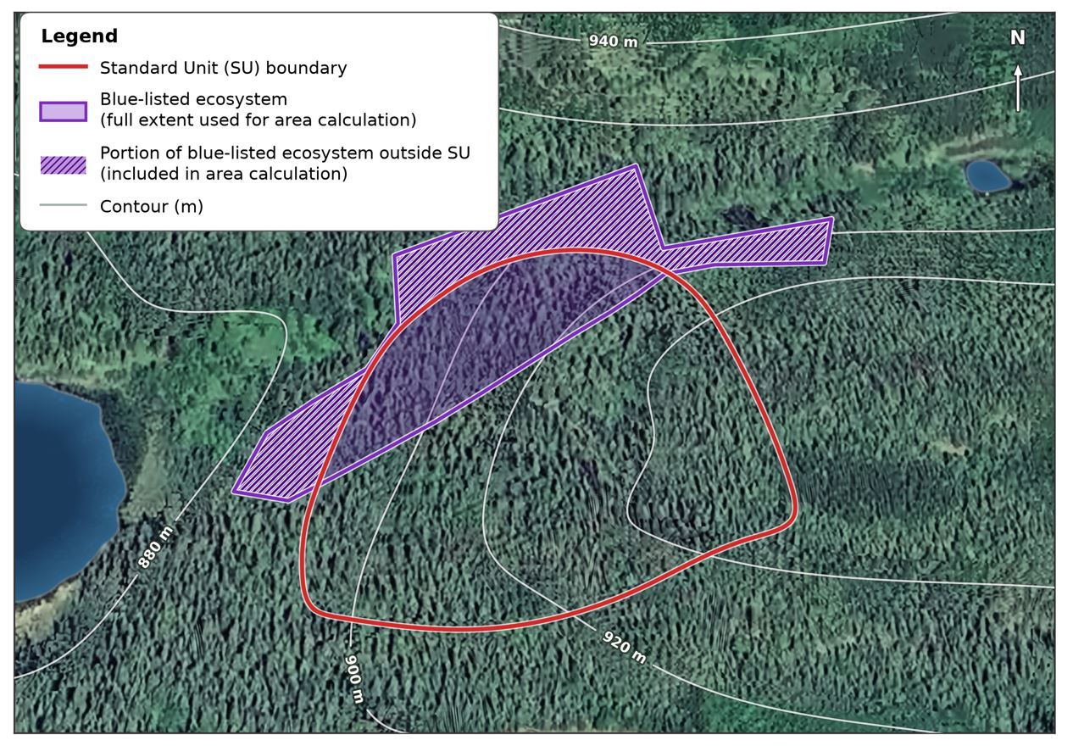

Figure 2: Determining Qualifying Listed Site Series as SU's (Image produced with GoogleEarth ProTM and GrokAi).

In the above polygons, the red line demonstrates an area proposed for development and the purple line is the known limits of a Blue Listed site series. The combined area, including transitional zones for this Blue Listed site series (which in this example is associated with a riparian feature), is over 4 hectares, regardless of the amount within the proposed block, and therefore qualifies for the protections in section 5.1.2.

5.2 Simple and Compound Ecosystem Delineation for SUs within the SMZ
The descriptions and edaphics of site series are broad and easily applied in the field by a properly trained, qualified person or professional. Most site series occupy 2 or more soil moisture regimes and 2 or more nutrient regimes. However, there are some very high-value habitats which do occur on very narrow edaphic ranges which have been historically blended into larger site series (mosaics). These plant communities are too important to be disregarded. The following are examples of acceptable practices for identification of standard units and some that would be problematic and should be avoided.
: Please refer to LMH 25 for details on mosaics.

5.2.1 Simple Compound Eco-typing (SCE)
Example 1: SBS dw3 01(10) — Referentially coded as: SS1(SS2)
Scenario: It is common to delineate areas where the site series classification is primarily of one site series with unmappable pockets of another type. Typically, these pockets do not add up to more than 10–15% of the standard unit and can easily be managed under one stocking standard provided that the minor site series portion is unmappable, or small pockets combine to less than 5 hectares (4 ha if blue listed). NOTE: RED listed plant communities MUST be mapped to the extent practicable if more than 1 hectare exists within the mosaic.
Example 1 describes an area that is primarily zonal (mesic); however, there are less than 10% pockets throughout of wetter depressions. This can be easily managed for by species selection, harvest retention planning, mitigation of potential vegetation competition, and other potential site and soil hazards. But it is important to recognise that these minor pockets of '10' site series provide unique microsites for a myriad of species that deviate from the '01' site types. So, in this example, SS1(SS2) could be an acceptable compound Standard Unit.

5.2.2 Complex Compound Eco-typing (CCE)
Example 2: SBS dw3 01₄₀ 02₃₀ 07₃₀ — Referentially coded as: SS1, SS2, SS3
Scenario: To operationalise a cutblock that occurs along a rich riparian feature, up a slope to the crest of a hill, it was combined into one generic stocking standard to provide operational ease. Thus, if it was a 100-hectare block, only 40 hectares are zonal (mesic); however, the stocking standard and management regime will have to provide for the other 60 hectares which have divergent edaphics.
This represents an example of complex, compound eco-typing of a standard unit which is unacceptable. To derive a singular management plan or stocking standard and prescription considering critical site and soil factors on all xeric, hygric, and mesic areas is poor management. Furthermore, within this new standards regime, it would cause issues with the required keystone species requirements. The site and soil hazards conflict with each other as well as the preferred and acceptable species overall. In this scenario there should be 2 or 3 standard units with 3 stocking standards and keystone targeted species.
The edatopic grid below for SBS dw3 demonstrates how under these new stocking standards, Douglas-fir is a primary species within the 02, 04, and 01 site series, whereas the primary species in the 07 and 08 is spruce.
Let's expand this example with real-world ecotypes:
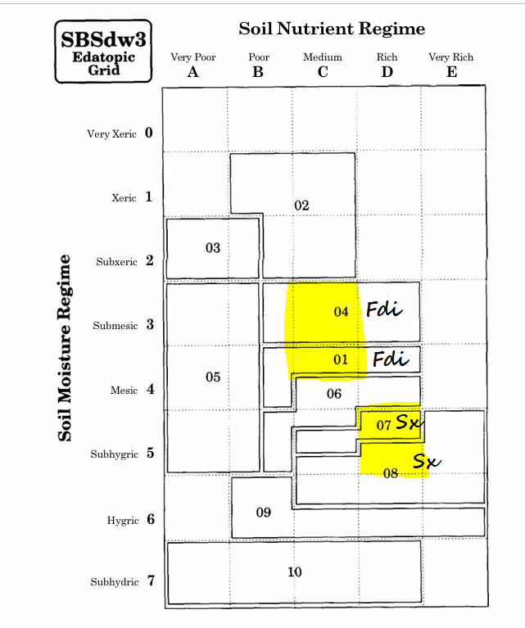

Figure 3: Example of Edatopic Grid for SBSdw3 and Lead SPP Correlation
(Reproduced from LMH 24; DeLong, Tanner, & Jull, 1993)

5.2.3 Compound Ecotyping on hummocky or mounded terrain
Example: SBS dw3 01/06 — Referentially coded as: SS1/SS2
Scenario: This type of ground does occur within the Shovel Lake ERP area and is typically formed not just from wetland hummocks, but also in areas where glacio-fluvial deposits create multiple 2.0-metre or greater terrain breaks within a lineal distance less than 50 metres (mounded). These areas often have elevated and depressional areas which cannot be stratified (in this example we have a mesic site with sub-hygric depressions). This type of compound ecosystem is rare but occurs and is not described well in older land management handbooks; they are denoted with a forward slash indicating split ecologies (50%/50%). In this example, it can be managed with an increase in spruce due to the wetter eco-type (06). Where a bona fide hummocky or mounded terrain exists, and the two site series would create a keystone species conflict (as in this example between Sx and Fdi), the ecology that is most likely dominant will form the keystone species requirement. However, true mounded areas are rare; qualified field assessments can determine this type of landscape feature.

5.2.4 Addressing Small Linear Patches and Transition Zones
Some of the highest value site series occur along karst, wetlands, streams, and lakes. Often there are transition zones where boundaries of variation between these ecologies blur, and the historic tendency has been to allocate these transition zones to the upland ecosystem site type. However, given the importance of these site series/plant communities, our review team has determined that it is important that these high value ecosystems (this would include small, linear patches, or stratifiable portions within mosaics) be typed and lumped instead into the smaller riparian standard units.
The following procedures determine the size of these small but extremely high value standard units:
- Where riparian, karst, spring, or other small high-value ecosystem (unique plant community) is identified:
  - Include the entire transition area into the linear or small patch and not into the larger upslope or other site series (standard unit).
  - Riparian site series do not have to be Blue Listed.
- Where the high value ecosystem does not have a transition zone:
  - Consider inclusion of the riparian management zone's area proportional to the proposed SU (example: if there is no transition zone to a richer, wetter site series adjacent to a riparian feature, consider inclusion of the entire RMA to enhance protection and management of that plant community as an SU).
- Refer to Section 5.6 for the importance of delineating riparian ecosystems as SUs and brush tolerances.

N.B. Lineal widths of transition zones rarely exceed 100 metres and are commonly 20–50 metres wide.
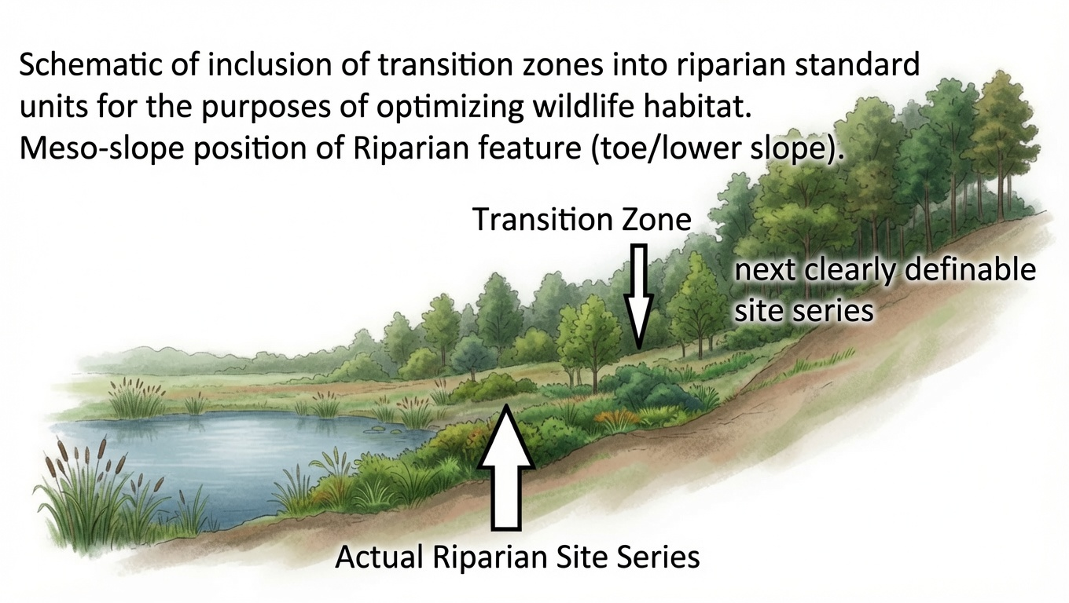

Figure 4: Example of Inclusion of Transitional Areas to Small Linear SU's (designed with assistance from Grok Ai)

5.3 Professional Accountability Documentation
Appendix 1 is the printout version of the Excel worksheets associated with outlining professional sign-off, standard unit details, rationales and a quick outline of critical site and soil factors (see Appendix 1). This accountability document provides the formal transparency in terms of professional practices for standard unit assignments.
To be able to monitor and manage changes in plant communities in BC, we must adhere to a more accurate and professional classification and distinction of SMR/SNR management regimes. Classification and identification of site series to manage for the future appropriate plant community trajectory needs to be the priority within the SMZs. One of the common misconceptions about site series versus plant communities is that logging and wildfires may alter the site series. However, while the seral stage of the site series may have changed, the climatic, geological, elevation, and degree days are all still the same—edaphically it's still the same site series. This BEC expression is still usually the best potential we have for managing and establishing a future plant community (mature/seral). Climate change and cumulative effects may shift soil moisture regimes; however, this will be difficult to track adequately with models if our standard unit data is not more accurately describing unique ecosystems.

5.4 Establishment of Mandatory Tree Species Minimums
The policy is currently in place where almost all stocking standards allow for lodgepole pine (Pli) to be a preferred species in virtually every site series in the SBS. This is important as without mandatory keystone species requirements, this means that at the time of free-growing, Pli can occupy 100% of the Silviculture Survey label, and overwhelm the inventory labels as well. The province, in response to requiring better information of all species within the stands, changed the requirements for data in the inventory layers to aid in better modelling. However, the use of inventory labels adjusted to tallies to 1% still does not incentivise the establishment of keystone species that may have slower early successional growth.
To address this for the SMZs, a mandatory minimum of specific ecologically suitable keystone species is mandated as part of the FG stocking/restoration standards. The stocking standards in this document identify a preferred target species minimum at FG (refer to Appendix 2 — Stocking Standards spreadsheet). This ensures a minimum of keystone species, critical to the future stand development pathway consistent with BEC mature forest patterns, are present and tallied at the time of FG declaration. To ensure tree species diversity is accounted for at the FG stage, this mandatory requirement will ensure future stands will include tree species diversity.
Selection of preferred and acceptable species as well as keystone species at FG are based on the careful analysis of existing information provided in Land Management Handbooks (LMHs) 24, 26, and others as well as the following:
- Klinka et al., 2000, Tree species silvics and comparisons.
- ClimateBC application.
- Climate Change Informed Species Selection Tool (CCISS) reviewed and referred to Bruce Rogers, Omineca Regional Ecologist, in 2023.
- Reviews of existing stocking standards within the business area.
- Chief Forester's FDP stocking standards.

5.5 MITD and Target Preferred and Acceptable Trees (TSSpa) – creating clumps and gaps
By increasing the targets of preferred and acceptable species (TSSpa) we increase the survey M-value. By coupling this with a lowered minimum inter-tree distance (MITD), we can allow for clumped growth of trees across the landscape as well as provide space for shrubs and vegetation. This better allows trees to optimise the microsites and allow for natural ingress patterns which should encourage more shrubs, herbs, and broadleaves for wildlife, moving the focus away from plantation-style, dense monocultures in SMZs.
Some deviations from this overall standard exist in BEC sub-zones and site series commonly associated with Caribou habitat within the stocking standards.

5.6 Addressing Vegetative Competition
Stocking standards typically have rules regarding free-growing assessments and the evaluation of brush species (competing non-commercial shrubs and broadleaves) impeding conifer tree development and survival. There are good reasons for this as vegetation can cause serious losses in plantation establishment, and some shrub species can occupy a large percentage of a site, excluding conifers for a long period of time. Aggressive removal, either by herbicides or mechanical brushing, can result in depletion of important food sources for a variety of animals. To ensure ecosystem restoration in an effective and efficient manner, the following methodology is applied for restoration standards within the SMZ of the ERP areas:
Relief within pre-identified riparian standard units:
- Interpretation of a riparian area is defined in the following circumstances only:
- The referenced riparian area is its own standard unit which correlates to a riparian feature and ecosystem (potential examples: SBS dw3 07*, 08*, 09*, 10*, Ws, Wb, Fm02. Note: "*" indicates that these site series do not always indicate riparian adjacency); and,
  - Brush and broadleaves are not considered deleterious to trees for the purposes of free-growing surveys.
- All other standard units are therefore non-riparian and must meet the vegetative competition criteria in the ERP-SMZ vegetation and broadleaf competition decision matrix as depicted in Figure 5.
- Within the SMZs, where vegetative competition reduces FG objectives, a minimum of one broad brushing treatment must be attempted before reduced stocking standards can be accepted.

  - Stocking standards reductions due to deleterious vegetative competition cannot exceed
20% of MSSpa (conifer portion) and Keystone trees for that standard unit at freegrowing survey.
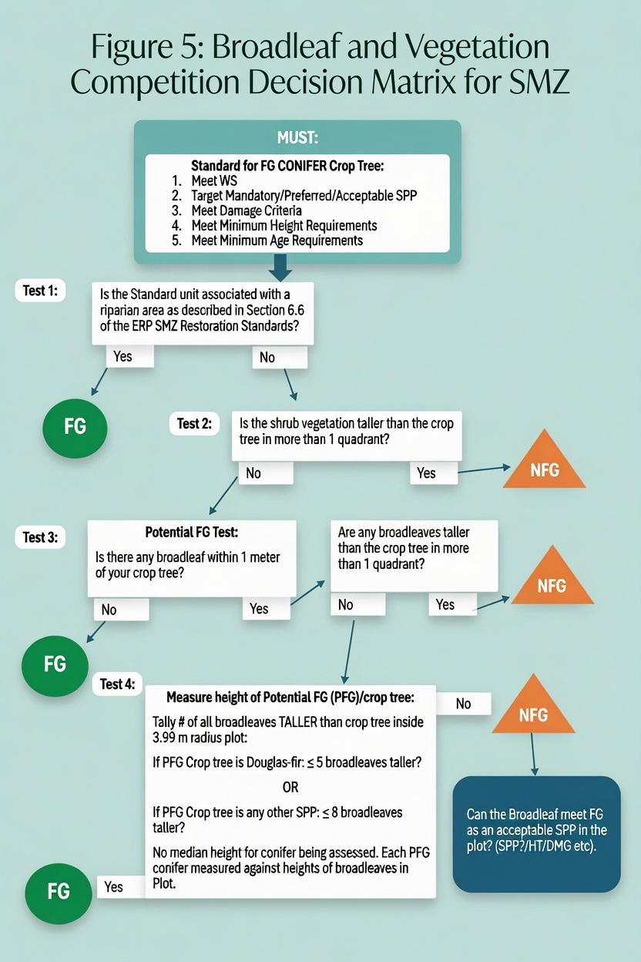

Figure 5: Broadleaf and Vegetation Competition Decision Matrix for SMZ (design with assistance from Grok Ai).

5.7 Broadleaves
Early seral forest development has evolved with intimate relationships between conifers and broadleaf species. Forestry practices over the last 50 years have eroded this vital interplay and its many soil, humus, and fungal benefits, particularly disease and pest resistance (Baleshta et al., 2005). While broadleaves can significantly impede or delay the development of conifer stands, the development of our current free-growing standards has evolved based on the research results from broadleaf thinning trials all over BC. This research indicates that broadleaf stocking is highly variable, depending on specific site elements, conifer and broadleaf species, and diseases.
The Interior Broadleaf Working Group (IBWG) has a methodology that relies heavily on a model that determines outcomes at year 80. The SERN BC Restoration Standards and Professional Practices team felt that within the ERP-SMZ areas, the key focus should continue to prioritize ecosystem discretion, keystone species establishment, gaps for understory vegetation, and a focus on ensuring that the distribution of broadleaves and conifers are more carefully established at years 10–20.
Careful assessment of ecosystems to standard units will determine competing vegetation and broadleaf tolerances for FG surveys. These stocking standards allow for broadleaves and other potentially competitive vegetation to not be considered deleterious on any standard unit associated with a riparian plant community. Upland standard units will follow the flowchart as laid out in Figure 5.
Within the SMZs, the desire to initiate a mixture of conifers and broadleaves and an assessment of their function at FG requires a variation of the broadleaf competition assessment. This variation to SMZ stocking standards will provide for broadleaf species as preferred and acceptable depending on the ecosystem standards. Where there may be a broadleaf species defined as preferred/acceptable, it may meet the FG objective if it is found that a potential free-growing (PFG) conifer does not meet the FG objective within that plot.
Figures 6 and 7 provide an example of how PFG conifers and the potential for accepting broadleaves as FG acceptable species could occur. In both scenarios the plot is composed of 4 conifers and either 8 or 10 broadleaves. In all cases FG plots will otherwise assess tree damage criteria and disease as per the Silviculture Surveys Manual.
Regarding incremental stand treatments between ages 20–40: this continues to be a forest management issue yet to be addressed and is beyond the scope of this rationale and restoration standard.

Example 1 (Figure 6): Crop Tree near Broadleaf 1 is Fdi. There is only competition within 1 quadrant. As there are 6 broadleaves as tall or taller than that Fdi, the Fdi is NOT FG; however, the broadleaf can be accepted as an FG tree if the stocking standard allows for that species of broadleaf as Preferred/Acceptable—and the broadleaf meets all other FG criteria (SPP, height, health). Note: for this plot example, there are hypothetically 4 countable conifers, which is less than the maximum density.
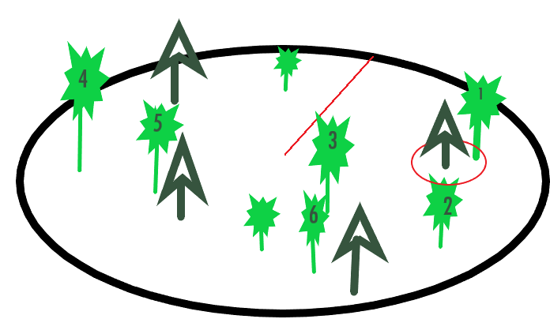

Figure 6: Example of Potential FG and Broadleaf Inclusion

Example 2 (figure 7): Assume conifer tree near Broadleaf 5 and 7 is a Spruce. The red line is the 1-meter circle around that spruce tree for potential free growing assessment purposes. If the two broadleaves are both taller than the spruce, and in separate quadrants, then this spruce is not FG. However, the spruce tree near broadleaf 1 could be considered FG as while there are two broadleaves, only one is taller than the spruce in only one quadrant. This potential FG spruce would be considered FG as fewer than 8 total broadleaves taller than that spruce within the entire plot. In both scenarios, there is an opportunity to instead mark the broadleaf as the FG tree, if it meets the species, preferred or acceptable and other criteria.
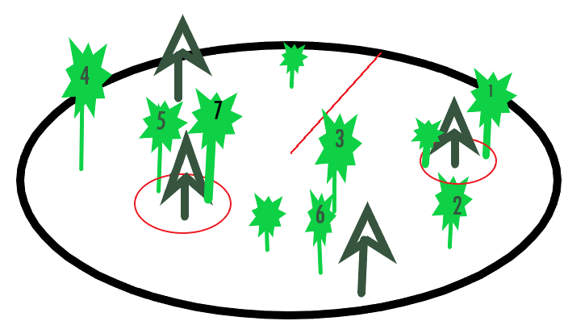

Figure 7: Examples of Conifer FG and NFG

5.8 Conifer and Broadleaf Maximum Density Management
The overwhelming professional opinion within the review team was that establishing an appropriate stand development pathway for the special management zones requires that we establish a maximum density for much of our site series at age 20, capped at 5,000 countable conifers (10,000 in selected Caribou-focused site series). The team felt that the policy shift removing mandatory density management overlooks the critical role of density management in mitigating inter-tree competition, enhancing stand resilience to pests and wildfires, and ensuring optimal future forest conditions, such as improved biodiversity (DeLong, 2019). Incentives or dedicated programs to fund this essential work essentially lean heavily on government funding for density control. Without statutory mandates or targeted financial support, many regenerating forests risk prolonged repression, reduced productivity, and failure to meet long-term ecological goals, underscoring an urgent need for reinstated obligations or enhanced incentives to safeguard BC's forest legacy. To that end, our restoration standards consider maximum densities to meet the needs within the SMZ in hopes that funding and policy will be forthcoming in the future.
Maximum density in all restoration units has been established. Maximum density includes total countable conifer trees only. The survey methods of 'countable conifers' will continue to be used consistent with the 2023 Silviculture Surveys Procedures Manual.
For even-aged silviculture systems: Countable Conifers will be measured as per the 2023 Silviculture Survey Manual methods.
Calculation of Countable Height:
Step 1. Determine the median height of the well-spaced trees in the plot (conifer). The surveyor should tally the tallest well-spaced trees. It is not required and can be detrimental to tally more well-spaced trees than the M value.
Step 2. Where the median height is:
- ≤2 m, the countable height is 30% times the median height as determined in Step 1.
- >2 m, the countable height is 50% times the median height as determined in Step 1.
Calculation of Median Heights:
Median height, as it is used for countable height, is defined as the "middle" height.
Procedural Steps:
- Identify up to the M-value number of well-spaced trees in the plot (best to select the tallest well-spaced trees).
- Determine the median height of the well-spaced tree. This involves measuring all the well-spaced trees; arrange their values in order from smallest to tallest. Select the height of the middle tree (for odd-numbered conifer counts), or the average height of the two middle trees (for even-numbered conifer counts).
Where conifer maximum densities are exceeded, we can determine if a particular species needs to be prioritized for treatment (spacing out). This could mean where excess lodgepole pine contributes to the maximum density, they are targeted in spacing treatments. Currently there is no legislation in place to ensure that this condition is met.

5.9 Facilitated Migration of yellow pine and western larch
Allelopathy refers to the chemical inhibition of one plant species by another through the release of biochemicals, known as allelochemicals, into the environment. Ponderosa pine (Pinus ponderosa), common within the southern interior forests, exhibits allelopathic effects that influence understory vegetation and ecosystem dynamics. The research on this species is well known and well documented. While western larch likely has allelopathic potential due to its production of secondary metabolites and ecological characteristics, direct evidence is limited. Studies on related Larix species and conifer allelopathy suggest that phenolic compounds, terpenoids, or other metabolites in needle litter or root exudates could inhibit understory growth or microbial activity (Lodhi & Killingbeck, 1982).
In consideration of the importance of plant communities, soil nutrition, and colder soils in the north, it was unanimously agreed by the SERN BC Restoration Standards and Professional Practices Group that within the SMZs, Py and Lw will not be planted. Instead, further studies and examination in other areas in the north where they are planted need to be undertaken to determine any future feasibility.

5.10 Free-growing and Regeneration Delay
Regeneration Delay: The goal of these standards is to allow for natural ingress to the extent practicable for most areas, shifting the focus to establishing keystone, Mandatory Minimum Tree Species instead of high-density planting of 'nurse trees'. To that end, these standards set no requirement for reporting regeneration delay (however, longer dates have been included in these standards as optional) as there is currently a regulatory requirement to do this.
Free-growing (FG): FG assessments cannot be conducted until the stand has grown on-site for at least 10 growing seasons. Thus, naturals can be FG at age 10; however, a planted stand with 1+0 seedlings must be 11 years old.

6.0 References
- Alexander, M.E. (2010). Surface fire spread potential in trembling aspen during summer in the Boreal Forest Region of Canada. The Forestry Chronicle, 86(2), 200–212. https://doi.org/10.5558/tfc86200-2
- Associated Strategic Consulting Experts Inc. (2019). Repression density treatment: Decision key (Prepared for Weyerhaeuser Company Ltd.). https://www2.gov.bc.ca/assets/gov/environment/natural-resource-stewardship/land-based-investment/forests-for-tomorrow/repression_density_treatment.pdf
- Baleshta, K., Simard, S., Guy, R., & Chanway, C. (2005). Reducing paper birch density increases Douglas-fir growth rate and Armillaria root disease incidence in southern interior British Columbia. Forest Ecology and Management, 208, 1–13. https://doi.org/10.1016/j.foreco.2004.07.076
- BC Ministry of Forests. (1995). Spacing guidebook: Forest Practices Code. Victoria, BC. Retrieved from https://www.for.gov.bc.ca/tasb/legsregs/fpc/fpcguide/space/SPA-TOC.HTM
- BC Ministry of Forests. (2022). Chief Forester's guidance on free growing obligations. Retrieved from gov.bc.ca/forestry
- Binkley, D., Sollins, P., Bell, R., Sachs, D., & Myrold, D. (1992). Biogeochemistry of adjacent conifer and alder-conifer stands. Ecology, 73(6), 2022–2033. https://doi.org/10.2307/1941452
- Bokalo, M., Comeau, P. G., & Titus, S. J. (2007). Early development of tended mixtures of aspen and spruce in western Canadian boreal forests. Forest Ecology and Management, 242(2–3), 175–184.
- Buck, J.R. & St. Clair, S.B. (2012). Aspen increase soil moisture, nutrients, organic matter and microbial biomass in semi-arid forests of western North America. PLoS ONE, 7(12), e52369. https://doi.org/10.1371/journal.pone.0052369
- Chen, H., Harmon, M. E., & Griffiths, R. P. (2004). Effects of woody root decomposition on soil carbon and nutrient dynamics in a coniferous forest. Plant and Soil, 263(1), 141–152. https://doi.org/10.1023/B:PLSO.0000047727.34662.8f
- Daust, D. & Price, K. (2019). Shovel Lake wildfire ecosystem restoration plan. Retrieved from https://sernbc.ca/uploads/library/additional_related/wildfire_recovery/Shovel_Lake_Wildfire_Ecosystem_Restoration_Plan_September_11_2019.pdf
- DeLong, C. (2019). Juvenile spacing in BC's interior forests: Ecological and economic rationale. BC Journal of Ecosystems and Management, 20(1).
- Forests for Tomorrow Program. (2023). Program overview. BC Ministry of Forests. Retrieved from for.gov.bc.ca/fft
- Garrison, M. T., Moore, J. A., Shaw, T. M., & Mika, P. G. (2000). Foliar nutrient and tree growth response of mixed-conifer stands to three fertilization treatments in northeast Oregon and central Washington. Forest Ecology and Management, 132(2–3), 183–198. https://doi.org/10.1016/S0378-1127(99)00230-5
- Haeussler, S., Coates, D., & Mather, J. (2002). Autecology of common plants in British Columbia: A literature review. BC Ministry of Forests, Research Branch. Retrieved from https://www.for.gov.bc.ca/hfd/pubs/docs/Lmh/Lmh49.pdf
- Hoecker, 2020.
- Johnstone, W. D., & van Thienen, F. J. (2004). A summary of early results from lodgepole pine thinning experiments in the British Columbia interior. BC Ministry of Forests, Research Branch. Retrieved from https://www.for.gov.bc.ca/hfd/pubs/docs/Wp/Wp51.pdf
- Keane, R. E. (2015). Wildland fuel fundamentals and applications (pp. 191–210). Springer. https://doi.org/10.1007/978-3-319-09015-3
- Klinka, K., Worrall, J., Skoda, L., & Varga, P. (2000). The distribution and synopsis of ecological and silvical characteristics of tree species of British Columbia's forests (pp. 180–189). Canadian Cartographics Ltd.
- Kranabetter, J. M., et al. (2016). Soil attributes and forest productivity in British Columbia's interior cedar–hemlock forests. Forest Ecology and Management, 376, 172–181.
- Kuzyk, G., et al. (2018). Moose population dynamics in central British Columbia. Journal of Wildlife Management, 82(4), 815–825. https://doi.org/10.1002/jwmg.21428
- Lodhi, M. A. K., & Killingbeck, K. T. (1982). Effects of pine-produced chemicals on selected understory species in a Pinus ponderosa community. Journal of Chemical Ecology, 8, 275–283.
- Lotan, J. E., & Critchfield, W. B. (1990). Pinus contorta Dougl. ex Loud. In R. M. Burns & B. H. Honkala (Eds.), Silvics of North America: Volume 1. Conifers (pp. 302–315). USDA Forest Service. Retrieved from https://www.srs.fs.usda.gov/pubs/misc/ag_654_vol1.pdf
- - MacDougall, A. (2022). [Full citation to be completed by author.] BC Ministry of Forests, Office of the Chief Forester.
- Mather, W. J., Simard, S. W., Heineman, J. L., & Sachs, D. L. (2010). Decline of planted lodgepole pine in the southern interior of British Columbia. The Forestry Chronicle, 86(4), 484–497. https://doi.org/10.5558/tfc86484-4
- Middleton, G. R., & Munro, B. D. (2002). Interior spruce and lodgepole pine sawlog quality. BC Ministry of Forests, Research Branch. Retrieved from https://www.for.gov.bc.ca/hfd/pubs/docs/Wp/Wp60.pdf
- Nesbit, K.A., Yocom, L.L., Trudgeon, A.M., DeRose, R.J. & Crookston, N.L. (2023). Tamm review: Quaking aspen’s influence on fire occurrence, behavior, and severity. Forest Ecology and Management, 531, 120752. https://doi.org/10.1016/j.foreco.2022.120752
- Page, W. G., Jenkins, M. J., & Alexander, M. E. (2014). Crown fire potential in lodgepole pine forests during the red stage of mountain pine beetle attack. Forestry, 87(3), 347–361. https://doi.org/10.1093/forestry/cpu003
- Parfitt, D., et al. (2010). Ecological impacts of forest management on soil and nutrient cycling in British Columbia. BC Journal of Ecosystems and Management, 11(1–2), 33–45.
- Pomeroy, J. W., & Gray, D. M. (1995). Snowcover: Accumulation, relocation, and management (NHRI Science Report No. 7). National Hydrology Research Institute, Environment Canada.
- Prescott, C. E., Maynard, D. G., & Laiho, R. (2000). Humus in northern forests: Friend or foe? Forest Ecology and Management, 133(1–2), 23–36. https://doi.org/10.1016/S0378-1127(99)00295-0
- Prescott, C. E., & Vesterdal, L. (2013). Tree species effects on soils in temperate and boreal forests: Emerging themes and research needs. Forest Ecology and Management, 309, 1–3.
- Redding, T., & Pike, R. (2007). Mountain pine beetle, forest practices, and watershed management (Extension Note 88). BC Ministry of Forests and Range. Retrieved from https://www.for.gov.bc.ca/hfd/pubs/Docs/En/En88.htm
- Redding, T. E., & Pike, R. G. (2007). The effect of mountain pine beetle attack and salvage harvesting on streamflows (Special Investigation Report No. FPB/SIR/16). Forest Practices Board, British Columbia. Retrieved from https://www.bcfpb.ca/wp-content/uploads/2007/03/SIR16-Effect-of-MPB-Attack-and-Salvage-Harvesting-on-StreamFlows.pdf
- Schmidt, W. C., & Shearer, R. C. (1990). Larix occidentalis Nutt. In R. M. Burns & B. H. Honkala (Eds.), Silvics of North America: Volume 1. Conifers (pp. 160–172). USDA Forest Service. Retrieved from https://www.srs.fs.usda.gov/pubs/misc/ag_654_vol1.pdf
- Schnorbus, M., Bennett, K., & Werner, A. (2010). Quantifying the water resource impacts of mountain pine beetle and associated salvage harvest operations across a range of watershed scales: Hydrologic modelling of the Fraser River Basin (Information Report BC-X-423). Natural Resources Canada, Canadian Forest Service, Pacific Forestry Centre. Retrieved from https://cfs.nrcan.gc.ca/publications?id=31207
- Swanson, M. E., et al. (2011). The forgotten stage of forest succession: Early-successional ecosystems on forest sites. Frontiers in Ecology and the Environment, 9(2), 117–125. https://doi.org/10.1890/090157
- Turner, M.G., Braziunas, K.H., Hansen, W.D. & Harvey, B.J. (2019). Short-interval severe fire erodes the resilience of subalpine lodgepole pine forests. Proceedings of the National Academy of Sciences, 116(23), 11319–11328. https://doi.org/10.1073/pnas.1902841116
- Wei, X., et al. (1997). Nutrient cycling in lodgepole pine forests: Impacts of harvesting and wildfire. Forest Ecology and Management, 96(1–2), 119–129.
- Winkler, R. D., Spittlehouse, D. L., & Golding, D. L. (2005). Measured differences in snow accumulation and melt among clearcut, juvenile, and mature forests in southern British Columbia. Hydrological Processes, 19(1), 51–62. https://doi.org/10.1002/hyp.5712
- Woods, A. J., Coates, K. D., Watts, M., Foord, V., & Holtzman, E. I. (2017). Warning signals of adverse interactions between climate change and native stressors in British Columbia forests. Forests, 8, 280. https://doi.org/10.3390/f8080280

Appendix 1: Professional Accountability Documents

1. RESPONSIBLE RPF IDENTIFICATION

Name of Responsible RPF | Licence Number
Employed By | Cutting Permit #

Gross Area (ha) | Net Area (ha) | Block Name | Amendment #

2. FIELD DATA COLLECTION
Information on soils, soil hazards, ecological field data collection, and critical site conditions was collected by the following persons:
Name of Qualified Person | Certification / Designation | Employed By

3. SUMMARY OF ASSIGNED STANDARD UNITS

SU # | Net Area to Reforest (ha) | Soil Texture(s) B layer | Coarse Frag. % B layer | SMR | SNR | SAR / Eco-systems | Critical Site/Soil Checklist
1 |  |  |  |  |  |  | ☐ Yes
2 |  |  |  |  |  |  | ☐ Yes
3 |  |  |  |  |  |  | ☐ Yes
4 |  |  |  |  |  |  | ☐ Yes
5 |  |  |  |  |  |  | ☐ Yes

4. PROFESSIONAL CERTIFICATION

I hereby certify that I, as the signing professional forester for this Site Plan, am satisfied that the field data collection, compilation of the checklist, identification of soil hazards and critical site factors have been described accurately and that I have assigned standard units that allow best management and mitigation strategies which will ensure, to the extent practicable, a healthy and resilient future forest.

Name of RPF | Certification Seal & Signature | Date

Standard Unit | # ______ | BEC Subzone & Variant | Site Series

If more than one site series are listed above, provide a rationale and strategy for managing them as a single standard unit:

SITE INFORMATION

Net Area (ha) | Aspect | Meso-slope Position | Average Slope % | Min Slope % | Max Slope %

B-layer Soil Texture | B-layer Coarse Fragments % | SMR | SNR | Soil Hazard Rating
Soil textures: S, LS, SL, SiL, L, SiCL, CL, C, Si, SC, SiC, HC · Soil Hazard: Compaction / Erosion / Displacement (indicate highest)
CRITICAL SOIL FACTORS

Factor | ☐ | Mitigation / Notes
Cold soils | ☐ | Site prep required? Higher Sx/Bl content?
Shallow soils | ☐ | Stock type concerns?
Deep organic layers | ☐ | Site prep? Species selection?
Skeletal soils (>70% CF) | ☐ | Stocking / planting considerations
Saturated soil season | ☐ | Often on very poor sites. Will logging increase saturation?
Fluctuating soil water | ☐ | Often on extremely productive sites (Act / Sx)
Heavy clay soils | ☐ | Compaction risk; equipment timing
Sands and gravels | ☐ | Drought / nutrient concerns
Other | ☐

CRITICAL SITE FACTORS

Factor | ☐ | Mitigation / Notes
Summer frost | ☐ | Species selection, retention strategies?
Frost heaving risk | ☐
Snow press / damage | ☐ | Cluster planting?
Cold air ponding | ☐ | Species selection, retention strategies?
Wind desiccation risk | ☐
Windthrow | ☐ | Windthrow assessment & block logistics reviewed
Short growing season | ☐ | Fall plant with larger stock?
Seasonal drought | ☐ | Species selection, retention?
Other | ☐

Appendix 2: Restoration Stocking Standards SMZ